**Math 120  
1.4 Linear Functions and Slope**

# Objectives:

1. Calculate a line’s slope.
2. Write the point-slope form of the equation of a line.
3. Write and graph the slope-intercept form of the equation of a line.
4. Graph horizontal and vertical lines.
5. Recognize the general form of a line and use x and y intercepts to graph the equation of the line.
6. Model data with linear functions and make predictions.

# Topic #1: The Slope of a Line

A line is determined by 2 points in the plane. The steepness of the line is calculated by finding the **________________________**between the 2 points. The slope is the ___________________ between any 2 points on the line; it can also be thought of as “rise over run”.



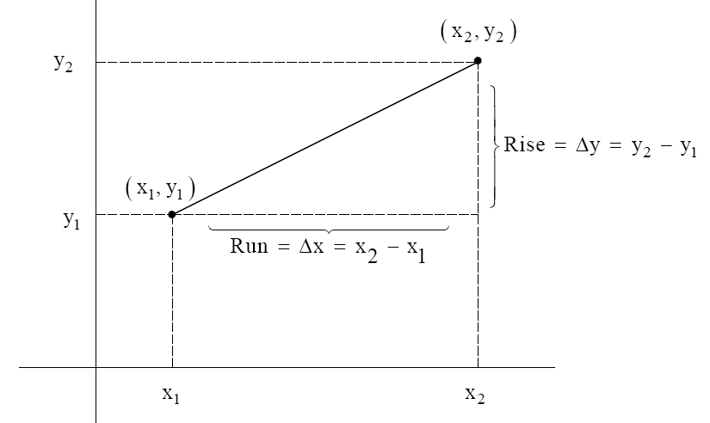

Definition of Slope:



*Example #1* – Find the Slope of the Line that Passes Through the Given Points

a) b)

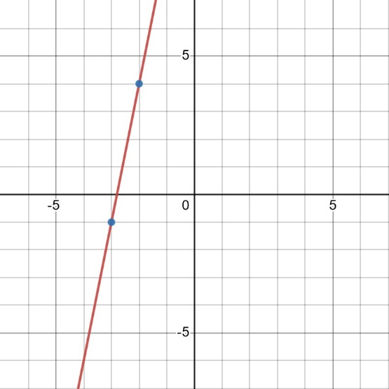 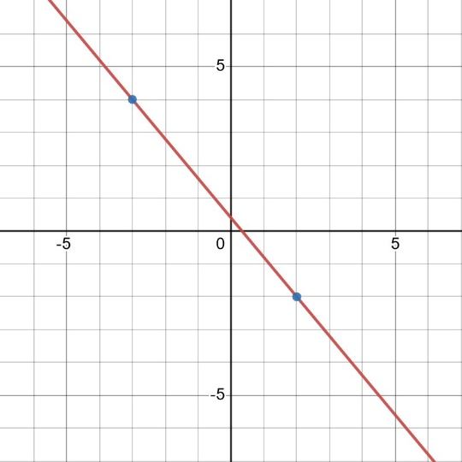

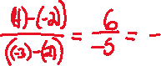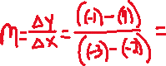

c) d)

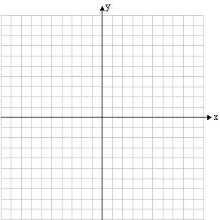 

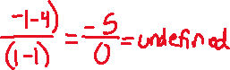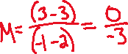

With the exception of the vertical line, the other lines represent ________________ where is a function of .



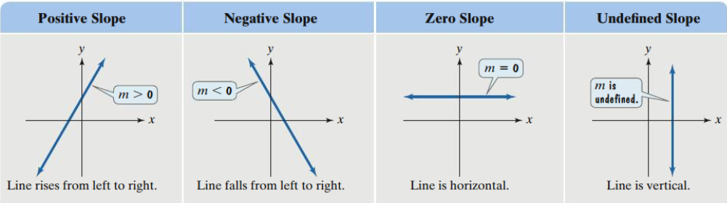

# Topic #2: The Point-Slope Form of a Line

As stated earlier, it takes 2 points to determine a line; if we have 2 points then we can find the equation of the line that contains the points (and all other points on it). Suppose 1 point is **fixed** at the point and the other point varies at .

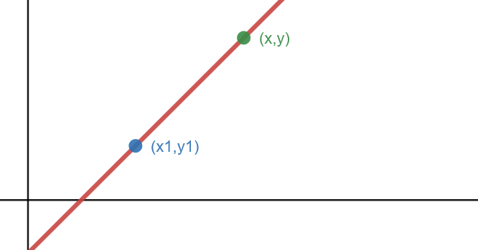

The slope of the line is:

Solving for gives us the **point-slope** **form of a line:**

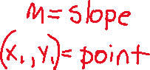

*Example #1* – Find the Equation of the Line with the Given Conditions, Write in Terms of



a) The slope is 5 and passes through the point .



b) The slope is and passes through the origin.



c) The line passes through the points .

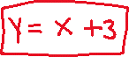

*YOU TRY #1*

1. Find an equation of a line going through the point

(-4, 1) and with slope .

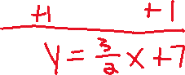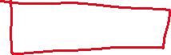

1. Find an equation of the line going through the points (2, 5) and (-3, 4).

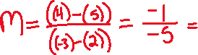

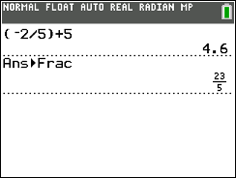

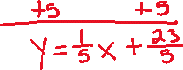

# Topic #3: The Slope-Intercept Form of a Line

When a line is expressed in the form **,** two main features of the line are revealed: its **slope** and its **-intercept**. As discussed earlier, the slope describes the rate of change (or steepness) of the line. The -intercept is where the line crosses the -axis, which is where . The associated ordered pair for any -intercept is denoted .

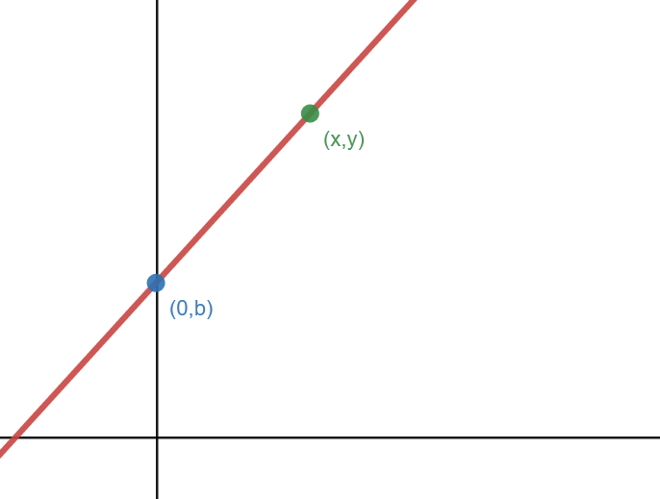

The slope of the line is:



Solving for gives us the **slope-intercept** **form of a line:**

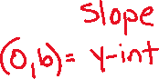

Notice the above examples using point-slope were all simplified to this form where is the slope and is where the line crosses the -axis. For the graphing calculator we need to enter the equation as “Y=”…

*Example #1* – State the Slope and -intercept and graph the line.











c)

Note this is not in slope-intercept form (it is in _________________, also called the _________________ form for the equation of a line). Let’s solve for by subtracting and from both sides of the equation to put in slope intercept like the examples above.







# Topic #4: Horizontal and Vertical Lines

A horizontal line has a slope of ZERO and passes through the -axis at the point . The point is also called the _______________________



* 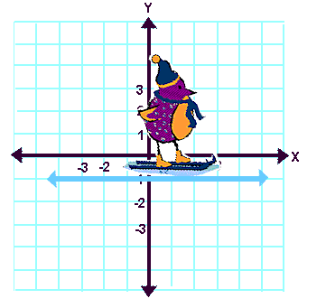A horizontal line has a slope equal to _______________



* (Ski Bird is not working hard to get up a hill, nor is he trying to slow down.  His energy level (and his enjoyment level) is at zero.)







The resulting equation for a horizontal line is . Since the slope of a horizontal line is ALWAYS zero, we could rewrite the equation in slope-intercept form: which simplifies back to the equation ___________________



A vertical line has an UNDEFINED slope and passes through the -axis at the point . The point is also called the _______________________



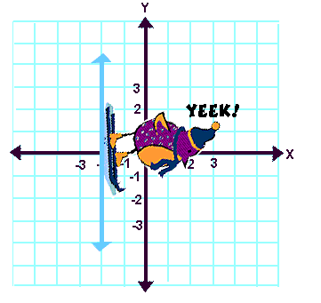

* A vertical line has an _________________________



* + - (Ski Bird cannot ski vertically.  **Sheer doom** awaits Ski Bird at the bottom of a vertical hill.)







The resulting equation for vertical line is . ***We cannot use function notation for a vertical line since the -values repeat so vertical lines are _________________***



*Example #1* – Graph the Line

a)





b)





*YOU TRY#2* –

1. Find the equation of a line going through the point (3,2) and the slope does not exist. Graph the line.







1. Find an equation of the line having slope of 0 and going through the point (3, -4). Graph the line.







# Topic #5: Modeling Data with a Linear Function

Linear functions can be used to fit data and make predictions. Consider the data set for life expectancy for men born in six selected years from a certain community. Let represent the years born after 1960 and represent the life expectancy (in years). This tells us a male born in 1960 corresponds to , a male born in 1970 is , and so on.

Let x be:



Let be:



| x | 0 | 10 | 20 | 30 | 40 | 44 |
| --- | --- | --- | --- | --- | --- | --- |
| y | 66.6 | 67.5 | 69.5 | 71.1 | 74.4 | 75.4 |

We can plot the data points with technology or we can plot the points by hand, just be sure to use an appropriate scale on the axes.

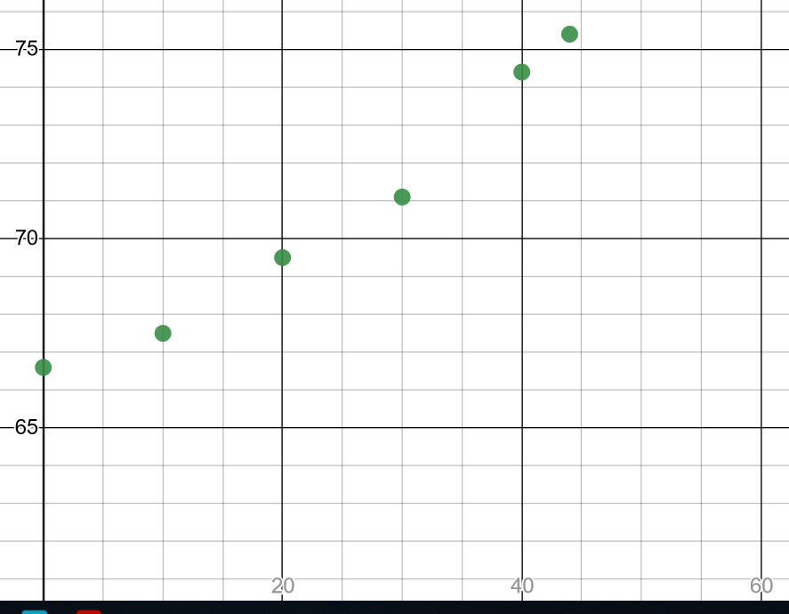

The points do not line up perfectly, but a linear function models the data *pretty well*. We can pick **ANY** 2 points from the data set and come up with a linear model.



Suppose we pick the points associated with a person born in 1980 and 2000; this corresponds to the ordered pairs: and .



To find the equation of a line, we first need the slope:

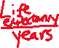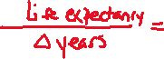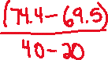

Now we have using the point in the point-slope equation gives:



A graph of the line fitting the data follows:

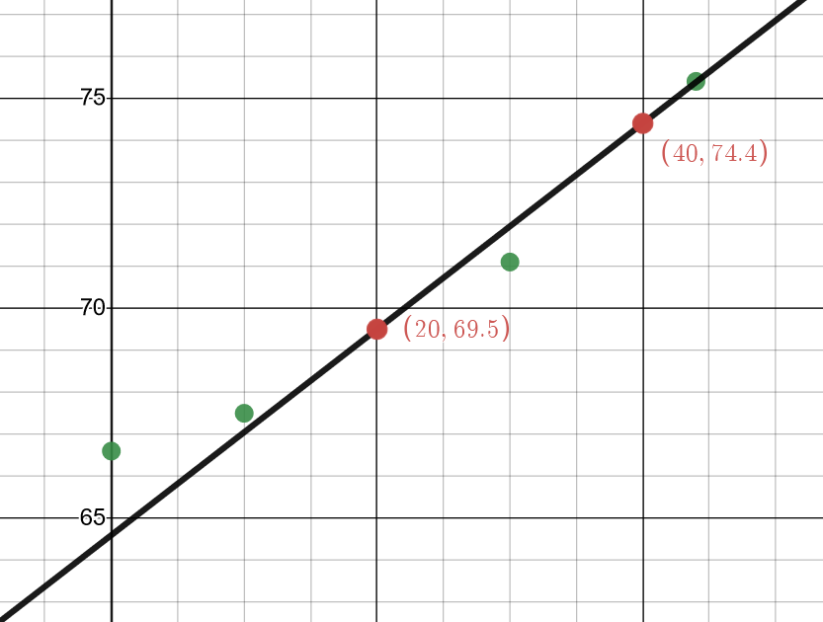

The line does a good job fitting the data and we can use it to make predictions:

Suppose we want to predict the life expectancy of a male born in 2020. This is 60 years after 1960 and corresponds to . Using our linear model from above:



The linear model tells us the predicted life expectancy for a male born in _____________________________



*YOU TRY #3* – Build a Linear Model to Make a Prediction:

| x | 0 | 10 | 20 | 30 | 40 | 44 |
| --- | --- | --- | --- | --- | --- | --- |
| y | 66.6 | 67.5 | 69.5 | 71.1 | 74.4 | 75.4 |

Use the data set above and the points associated with a male born in 1970 and 1990 to build a linear model. Use the model to predict the life expectancy of a male born in 2020.

Let x be:



Let be:



Looking at the data set, we use the ordered pairs:



To find the equation of a line, we first need the slope:

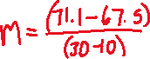

Using slope and either point we can write the point slope equation and solve it for y:



A male born in 2020 corresponds to , use the model to find *f*(60). Interpret your answer IN A COMPLETE SENTENCE:



Notice our prediction for the life expectancy of a male born in 2020 varied depending on what 2 points we used to construct the model.